28.12: The total magnetic field is the vector sum of the constant magnetic field and the wire’s magnetic field. So:
a) At (0, 0, 1 m): 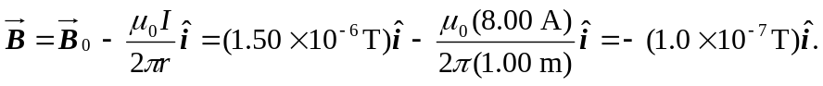
b) At (1 m, 0, 0): 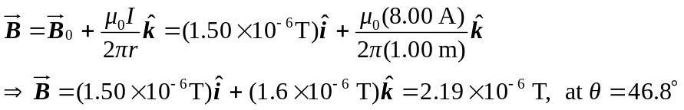
from x to z.
c) At (0, 0, – 0.25 m): 